Send Daily DB Backup Report via a SQL Agent Job (Author: [SANJAY HUMANIA](https://www.ourtechideas.com/blog/author/sanjay/))

<https://www.ourtechideas.com/blog/database-backup-report-via-email/>

# Scenario

Send Database backup report daily by a Job. Here we will use a TSQL script for the activity.

The script will create two temporary tables for the activity and use Database mail profile to send the report via email.



# Steps

1) First Configure Database mail in SQL Server if it is not configured before. You can follow the link for instruction: <https://www.ourtechideas.com/blog/configure-database-mail/>

2) Create a Job for the activity & schedule as per your requirement

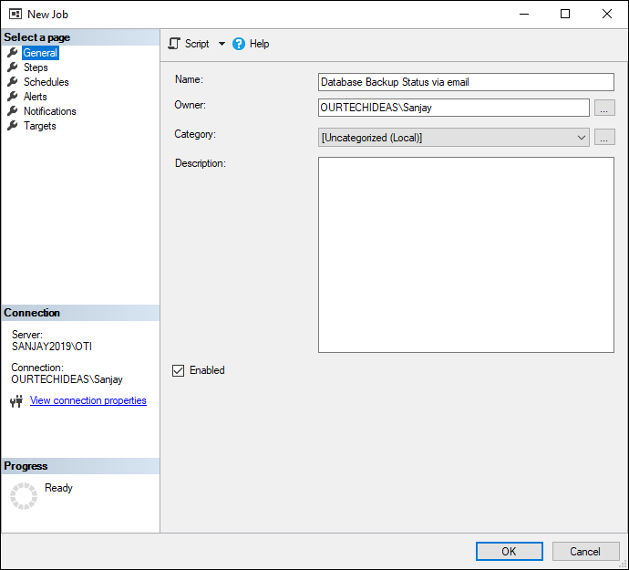

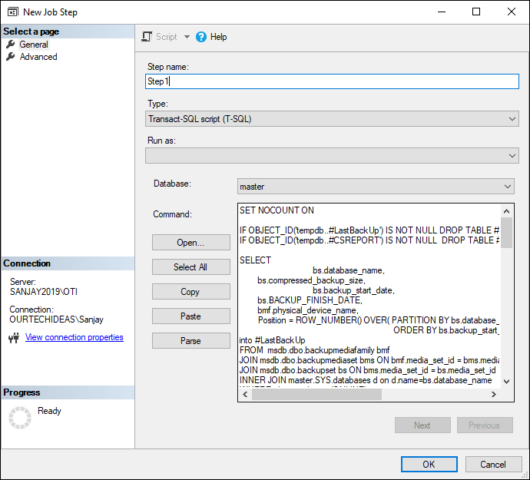

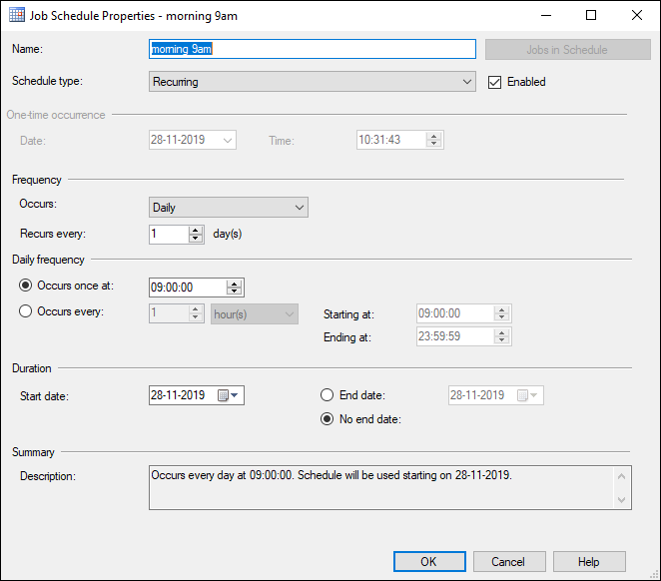

3) Modify the script & use it in the Job

* *Must modify in the script*
  + *Email Sender Name*
  + *DB Mail Profile*
  + *Recipients Email*
  + *Copy Recipients Email*

**TSQL Script**

SET NOCOUNT ON

IF OBJECT_ID('tempdb..#LastBackUp') IS NOT NULL DROP TABLE #LastBackUp;

IF OBJECT_ID('tempdb..#CSREPORT') IS NOT NULL DROP TABLE #CSREPORT;

SELECT

bs.database_name,

bs.compressed_backup_size,

bs.backup_start_date,

bs.BACKUP_FINISH_DATE,

bmf.physical_device_name,

Position = ROW_NUMBER() OVER( PARTITION BY bs.database_name,bs.[type]

ORDER BY bs.backup_start_date DESC ),d.recovery_model_desc,bs.[type]

into #LastBackUp

FROM msdb.dbo.backupmediafamily bmf

JOIN msdb.dbo.backupmediaset bms ON bmf.media_set_id = bms.media_set_id

JOIN msdb.dbo.backupset bs ON bms.media_set_id = bs.media_set_id

INNER JOIN master.SYS.databases d on d.name=bs.database_name

WHERE d.state_desc = 'ONLINE'

AND d.is_read_only = 0

AND d.source_database_id IS NULL

and ISNULL(bs.backup_finish_date, GETDATE()-1) > GETDATE() - 3

SELECT

@@servername as servername,

CASE WHEN ISNULL((backup_finish_date), GETDATE()-10000) < GETDATE()-31

AND [type] = 'D' THEN 'FAILED'

WHEN ISNULL((backup_finish_date), GETDATE()-10000) < GETDATE()-1

AND [type] = 'I' THEN 'FAILED'

WHEN ISNULL((backup_finish_date), GETDATE()-10000) < GETDATE()-1

AND [type] = 'L' THEN 'FAILED'

WHEN [type] IS NULL THEN 'FAILED'

ELSE 'BACKUP SUCCESS' END AS BackupStatus,

datediff(d, (backup_finish_date), getdate()) as 'full_dayssincelast',

CASE WHEN [type] = 'D' THEN 'Full Backup'

WHEN [type] = 'I' THEN 'Differential Backup'

WHEN [type] = 'L' THEN 'Transaction Log Backup' END AS BackupType,

database_name as databasename ,

recovery_model_desc AS RecoveryMode,

backup_start_date,

BACKUP_FINISH_DATE,

CAST((compressed_backup_size) / 1048576 AS DECIMAL(10, 2) ) AS backup_size_mb,

physical_device_name as path,

GETDATE() as insert_date

INTO #CSREPORT FROM #LastBackUp

ORDER BY backup_finish_date desc

DECLARE @tableHTML NVARCHAR(MAX) ;

declare @servername varchar(max)

set @servername=@@SERVERNAME

SET @tableHTML =

N'<H2>Database Backup Status </H2>' +

N'<table border="1" Cellspacing="0" cellpadding="0" style="font-size:x-small;">' +

N'<tr style="background-color:#999999;color:black;font-weight:bold;" align="center">

<td>ServerName</td>' +

N'<td>BackupStatus</td>' +

N'<td> BackupType</td>' +

N'<td> Databasename</td>' +

N'<td> RecoveryMode</td>' +

N'<td> Backup_start_date</td>' +

N'<td> BACKUP_FINISH_DATE</td>' +

N'<td>Backup_size_mb</td>' +

N'<td> Path</td></tr>' +

CAST ( ( SELECT

td = ServerName,'',

td = BackupStatus,'',

td = BackupType,'',

td = Databasename,'',

td = RecoveryMode,'',

td = Backup_start_date,'',

td = BACKUP_FINISH_DATE,'',

td = Backup_size_mb,'',

td = Path,''

FROM #CSREPORT

FOR XML PATH('tr'), TYPE

) AS NVARCHAR(MAX) )+

N'</table>' + N'<BR><BR><BR><BR><BR>Thanks<BR> Sanjay Humania<BR><BR><BR><BR><BR>' ; -- Email Sender Name

if (select count(*) FROM #CSREPORT) > 0

Begin

declare @sqlstr varchar (500)

set @sqlstr = 'Database Backup Information '+ @servername

EXEC msdb.dbo.sp_send_dbmail @profile_name = 'SQL_DB_Email', -- DB Mail Profile

@recipients='sanjay.humania@gmail.com', -- Recipients Email

@copy_recipients = 'sanjayhumania@gmail.com', -- Copy Recipients Email

@subject = @sqlstr,

@body = @tableHTML,

@body_format = 'HTML' ;

End

# Sample Mail Result

